# **Documentation of Subdomain Status Checker Script**

1. Install python3 using pip =

**“sudo apt install python3-pip”**

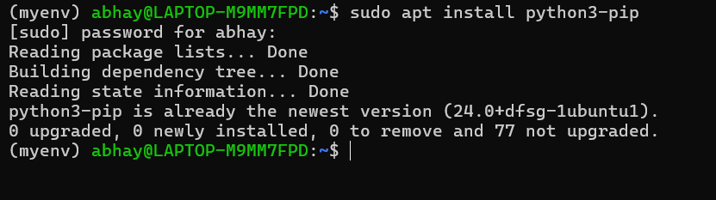

1. Libraries Installation =

**“pip install requests tabulate schedule”**

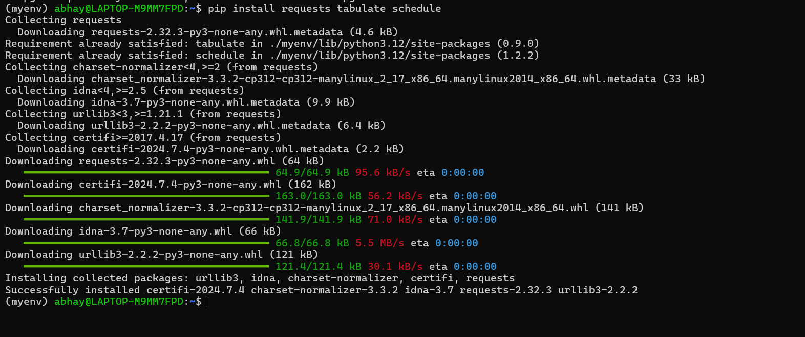

1. Script**: check_subdomains.py =**

Create a Py thon file named check_subdomains.py and add the following script:

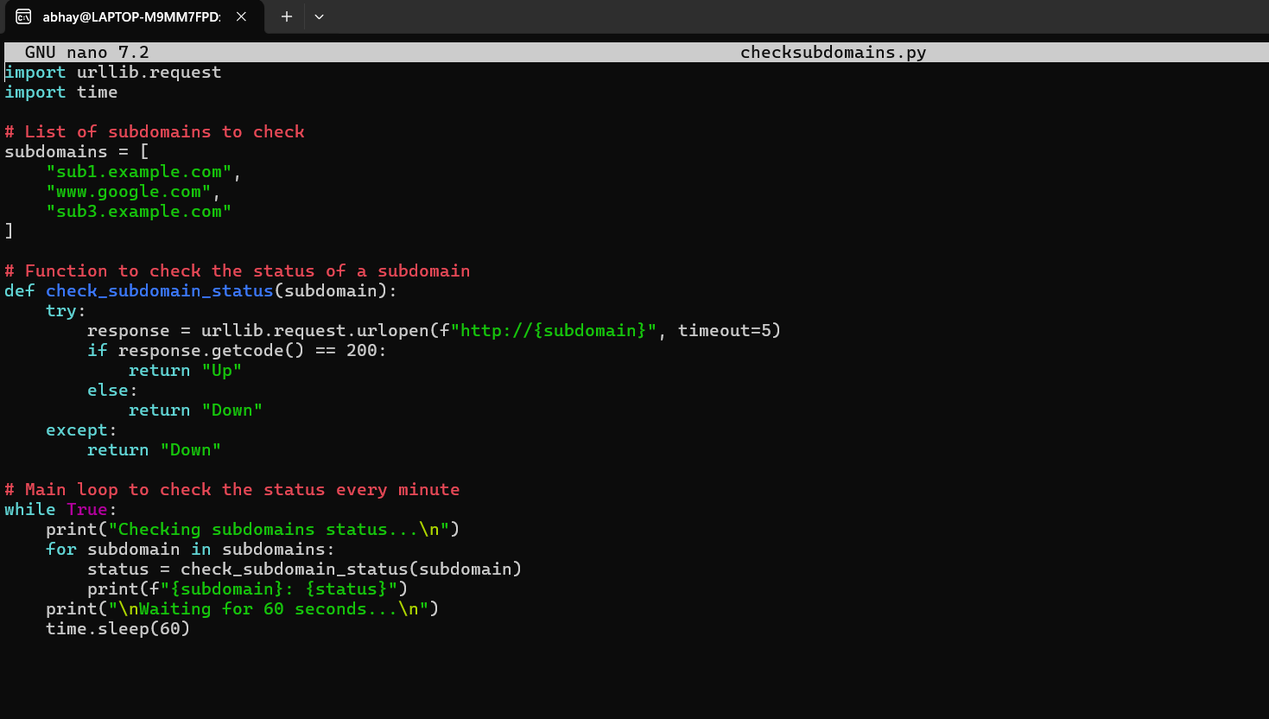

1. Running the Script =

“**python3 checksubdomains.py”**

